SVN Build
- Step 1:
First Open the Putty and give
Host name : root@10.101.120.175
Default Settings : 10.101.120.175
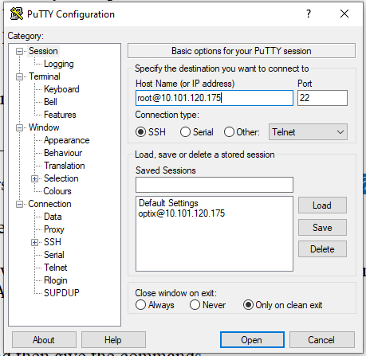
- Step 2:
- It will open the putty command prompt and provide the PASSWORD (password should be confidential)
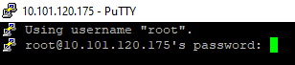

- Step 3:
- give the commands for :
- Pwd ( To go the root folder)
- ps -aux|grep svn (To see which SVN serve is running currently)

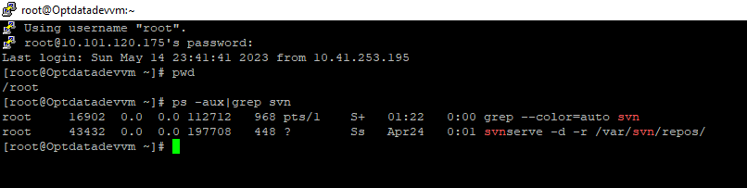

- First create the folder: cd /var/svn/repos/ for the repo you want to create
- cd /var/svn/repos/ ( go to this Path to check the all Repositories)
- ls –lrt (To see all repositories)

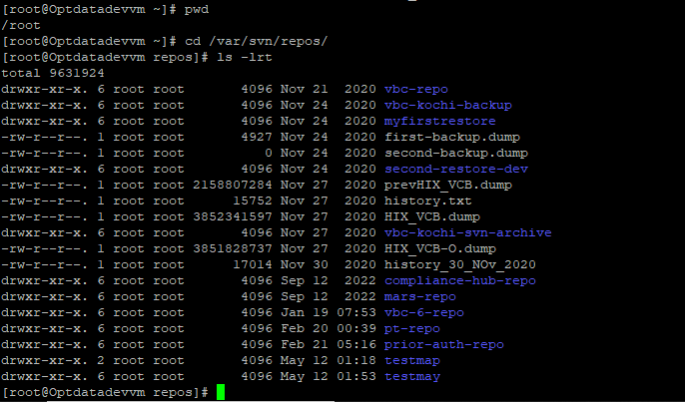

- Step 4:
- Open WinSCP and go to the root_175 (or) give the
Host name : root@10.101.120.175 and password (Step 2)
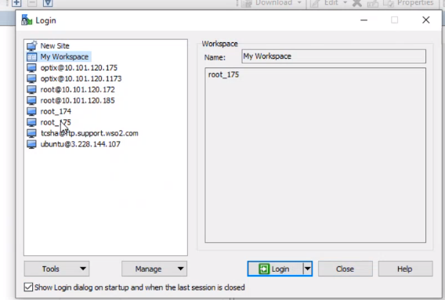
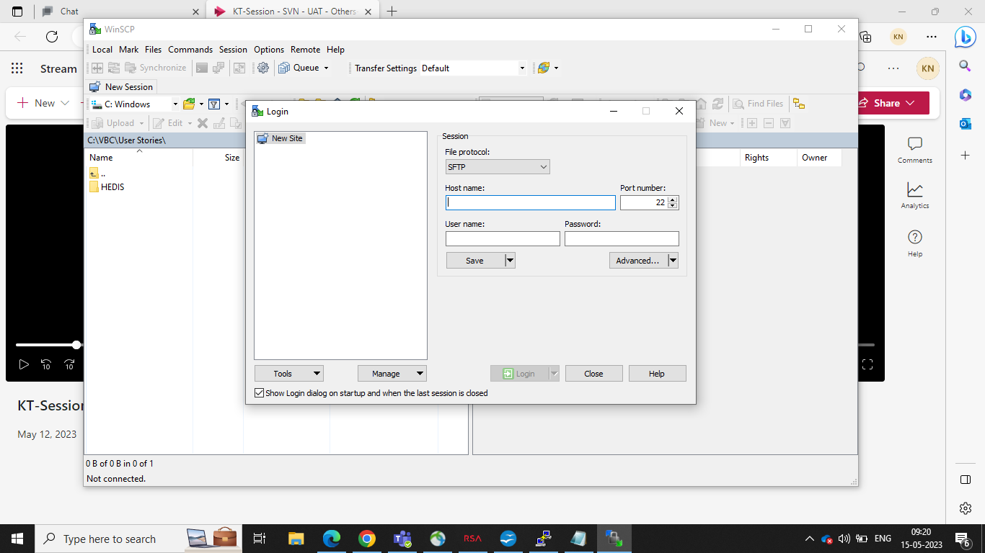

- Step 5:
- Give the Commands for creating the Repository
- mkdir testjune (To create a Directory where testjune is the demo repository which we are creating)
- svnadmin create testjune (To create a Repository)
- After creating Repository, you can able to see the Db and conf related files in WinSCP
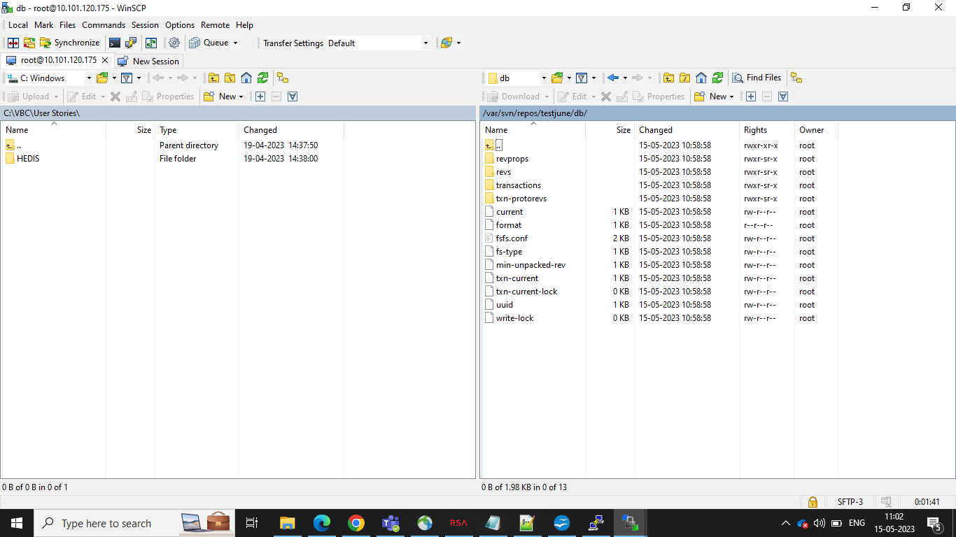
- vi testjune/conf/passwd (To give the password credentials)
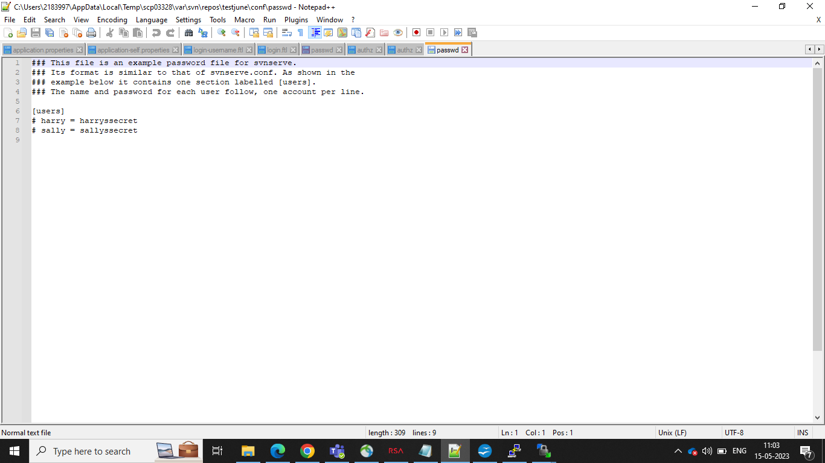
- Here , we need to give the password credentials to users and to edit the text, click control+I and make changes in the file.
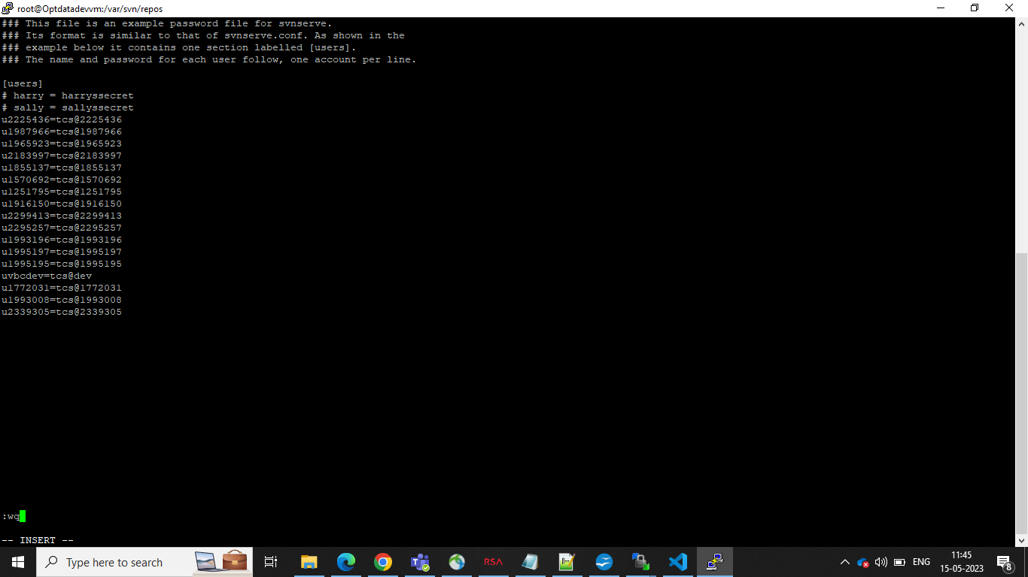
- If you want to go back , control+c and write :qw and enter.
- vi testjune/conf/authz (To give the Read and Write Access to users)

- 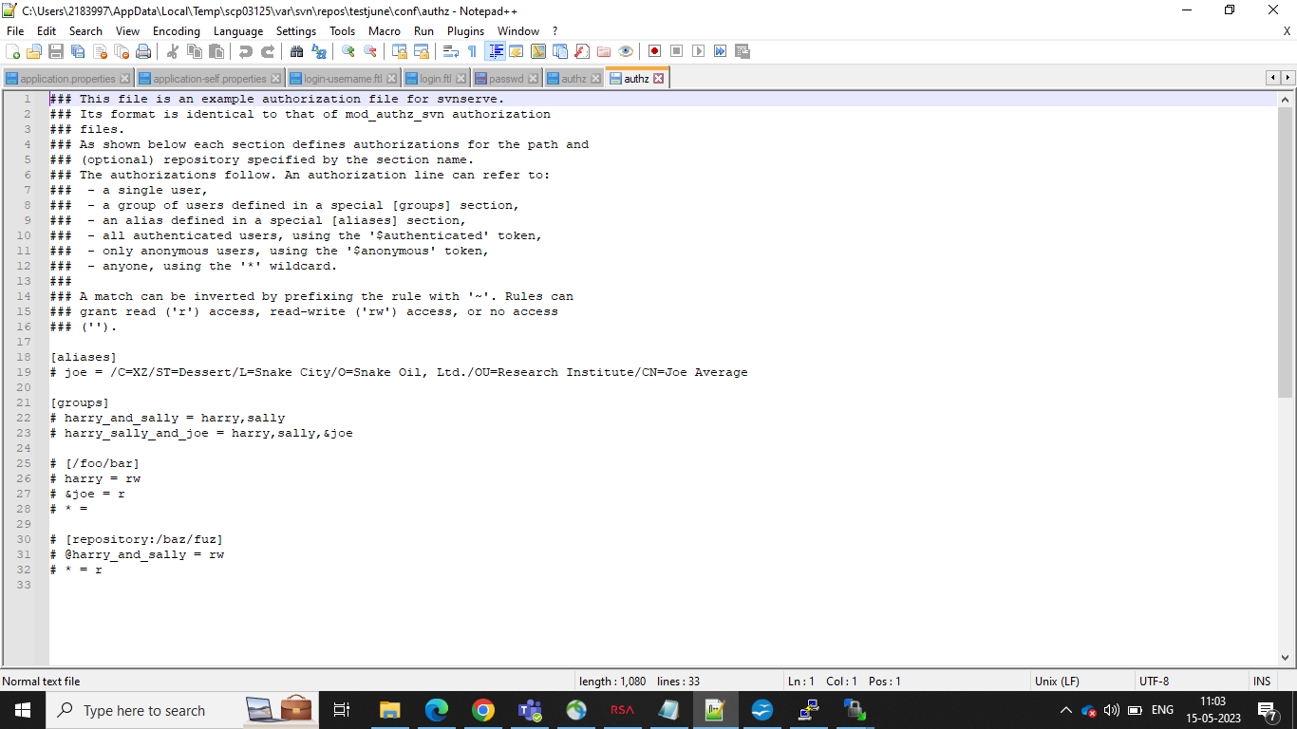
- Here, we need to give Read and Write access or else you can give readonly access to the users and to edit the text, click control+i and make changes in the file.
- If you want to go back, control+c and write :qw and enter.

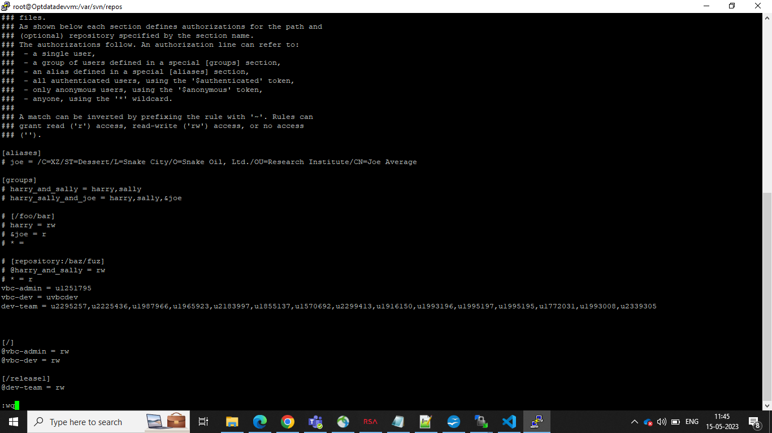

- vi testjune/conf/svnserve.conf (TO check the anon-access, auth-access, password-db,auth-db should make as uncomment these four commands)
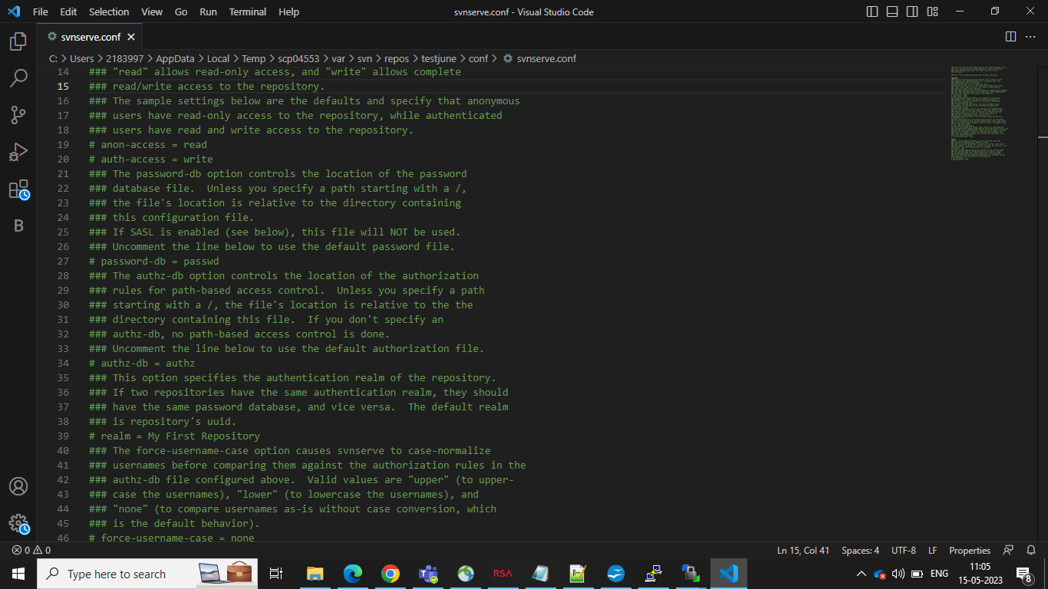
- Here , we need to uncomment the four commands which are :
  - anon-access = none
  - auth-access = write
  - password-db = passwd
  - authz-db = authz
- If you want to go back , control+c and write :qw and enter.
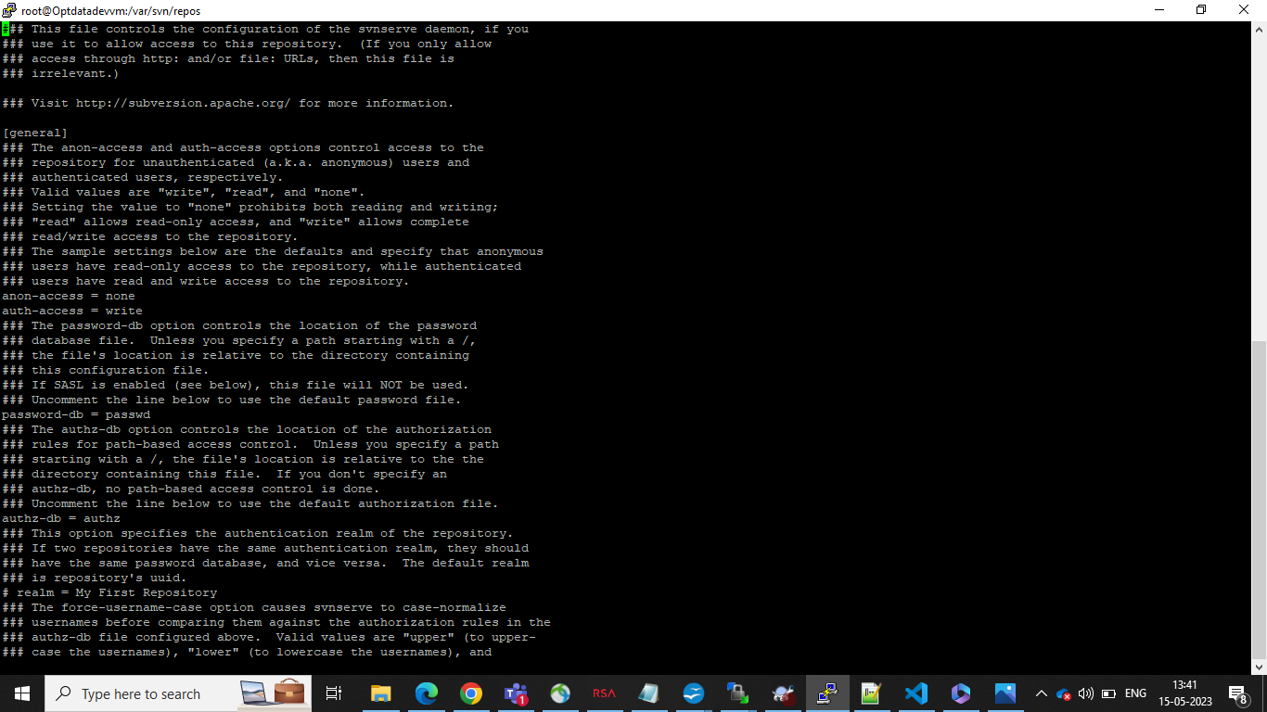

- Step 6:
- Go to the local path in your system and create a folder and take SVN checkout and use the link: svn://10.101.120.175/testjune/release1
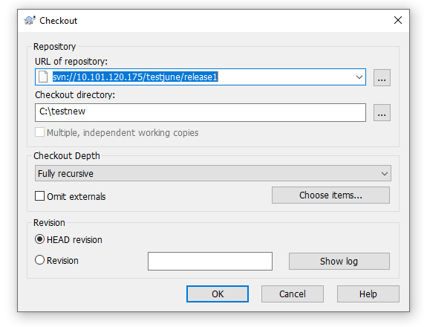
- After that you need to give the credentials
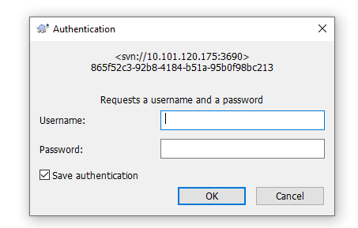
    - For Vbc_admin (username: uemployeeid and password : tcs@employeeid)
    - For Vbc_dev (username: uvbcdev and password : tcs@dev)
    - For dev_team (username: uemployeeid and password : tcs@employeeid)
- Step 7:
- To see all Repository files, the command is :
ls /var/svn/repos/
- To Remove the Repository, give the command:
rm -r testjune
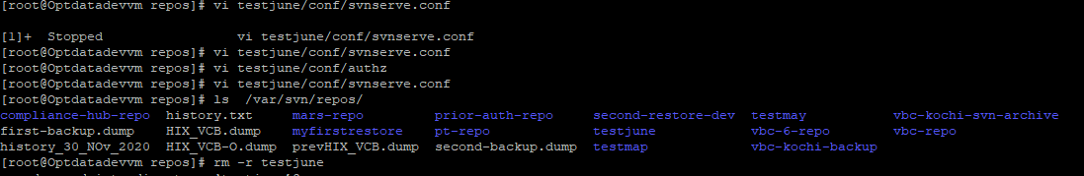
- To Remove the all files in Repository, the command is :
rm -rf testjune
